From guest article: https://www.nickplayschess.com/p/smiling-in-the-drought

Smiling in the Drought
A philosophical approach to addressing worse positions

So much of chess has to do with taste. What positions do we enjoy playing? Does our opening suit our traits? This is where chess confidence against stronger players comes from during games themselves, where we know our comfort zone better than our opponent. Here, “trait” includes all facets of the game, including imbalances. The term is meant to be general.
Here’s a perspective you may have never thought of. Take two players in which one is strikingly more advanced than the other. There are more qualities of play that the stronger player is better at than the weaker player. When the weaker player wins (without any major tactical/material blunders by either player), it is because of all traits in chess, the game happened to swing towards that one trait that was advantageous to the weaker player.

Intuition, or, your ability to naturally find good moves, is strengthened when looking at traits that are advantageous to you. For instance, players play closed openings, not just because they “liked” closed positions - it’s because they can find moves easier in the resulting positions. Players like positions that they can play with ease. This is the mechanism on how to win positions you are deeply uncomfortable with, i.e. “to smile in the drought”.

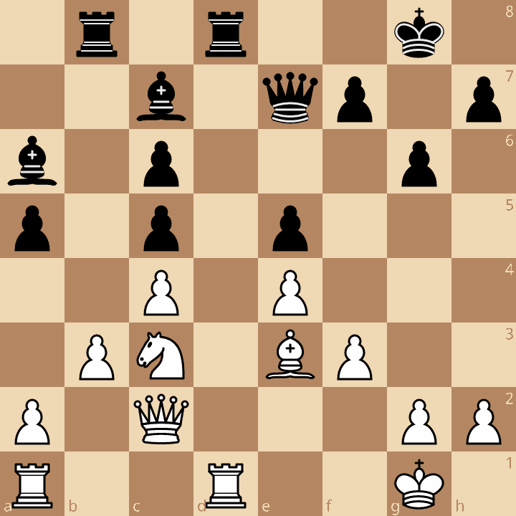
Ljubinksy- Botvinnik, Moscow 1943. Black to play.
This game is very famous. I will intentionally omit the evaluation. This position is typical of many games. It is increasingly restrictive, with very little by way of plan.
Think about this position for a while. What would you play as Black? What ideas are available to each player?
- For Black: Rook lifts or breaks like 1…a4 or 1…f5 are highly ineffective. Similarly, attempts to double the rooks are quickly thwarted. For instance: 1…Rd7 2.Rxd7 Qxd7 3.Rd1 or Bxc5. Any Bishop maneuvers are too slow in the face of White’s plan.
- For White: His plan is very simple. Qf2 and Na4, followed by slowly outplaying the opponent with a queenside majority, or on the dark squares. This has the positive side effect of preventing …Rf8 via the Bxc5 skewer.
Here, White will spend less time, find better moves, and take advantage more directly when Black is forced to make passive or weak moves. A key move in any instance for Black is Bc8, which cuts off the rook connection. This is always a gate that Black needs to cross for any plan, leaving him weak for at least one move.
With normal play, White will slowly pick up more and more of an advantage until Black is crushed into oblivion!
However, you would be incorrect to throw up your hands and say “Bah! Black is suffering! It’s almost lost!”
You wouldn’t be incorrect in your evaluation; computers seem to give around +0.8 to +1 for White. You would be guilty of not appreciating chess. You will play the Black pieces at some point, and it is your responsibility to play winning chess with those Black pieces.
1…Rd4!

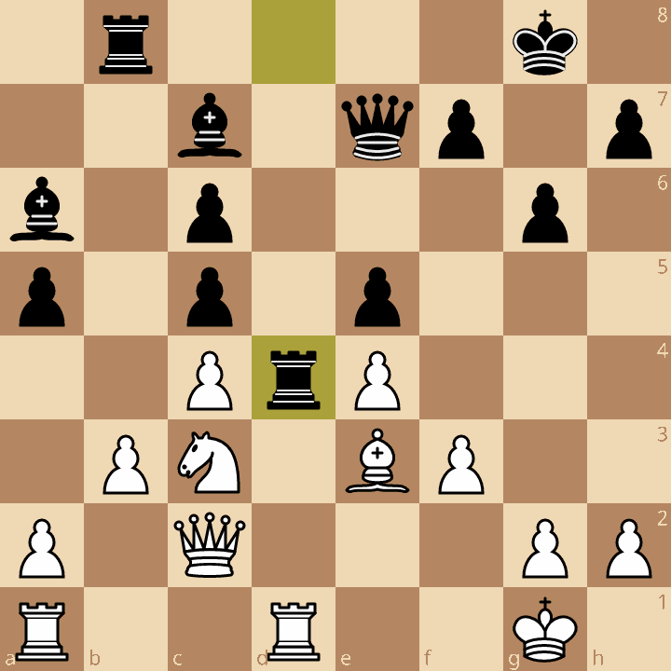

This is the best move in the position, because it interrupts White’s plan of attacking c5 and closes the file. Generally, a closed game favors Black, because it provides more time for Black to enact his plans. New open lines can be taken advantage of, such as the f-file, which Black can dominate with specific f5-breaks. In fact, this is what occurred in the game.
The second- and third- best moves are 1…Kg7 and 1…h5, which are slightly worse (by 5 centipawns). However, their benefits are artificial. Each attempts to create strength on the kingside via expansion and advance of the pawns. This makes some sense, as it contributes a positive imbalance to Black’s position: space. However, it doesn’t answer White’s threats, nor creates major threats of Black’s own. It’s not forcing enough.
You’re not a computer. You play human moves and response to human threats. For that reason, you should build up your stamina in order to think of and play moves like 1…Rd4. It is difficult to give up any exchange, but ultimately, you can bring the game back to your turn. Once more, even if Rd4 was not the best move in hindsight, it was still the best move to play.
To tie the bow, think of Black’s position as a drought of ideas. Nothing traditional quite seems to work. You are in the desert and looking North, East, West, and South, and there is nothing to be found. You smile, knowing there is somewhere else yet to look. You will not sit idly hoping for rain, but you begin to dig downwards. Your nails get mud in them and it’s far more stressful, but it’s your best shot.
Sometimes there’s no water. Sometimes there are more droplets than on the surface. And sometimes (more often than you think), you, like Botvinnik, can find a pool of groundwater.

